Supporting Parents with Learning Disabilities in Scotland: the Challenges and Opportunities 2016

Easy Read Recommendations

What this report is about
   | SCLD asked Strathclyde University to find out how parents with learning disabilities are being supported in Scotland.
 | Strathclyde University wrote a report about what they found out.
 | This is an Easy Read version of the recommendations from the full report.
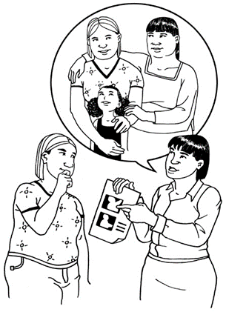 | Recommendations are things that the report says need to happen to make things work better for parents with a learning disability.
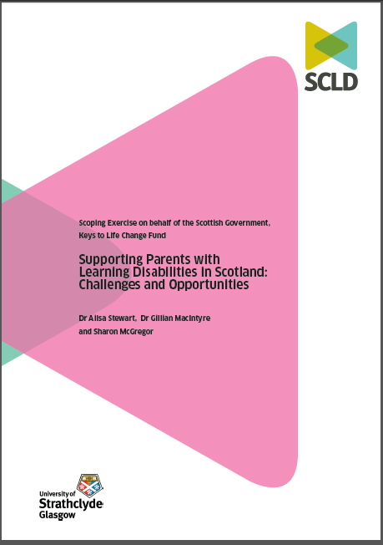 | The full report is called Supporting Parents with Learning Disabilities in Scotland: Challenges and Opportunities.  You can get a copy of the full report from SCLD if you want to read it.

Introduction

 | Parents with a learning disability living in Scotland should be supported better.
 | The support parents receive should be planned and delivered better.

Recommendation 1
  ? | We need to know how many parents with a learning disability are living in Scotland.  This is so we can plan support better.
Recommendation 2
 | We need to make sure that everyone who needs support is found.  This is so that they can get support early enough to make a difference.
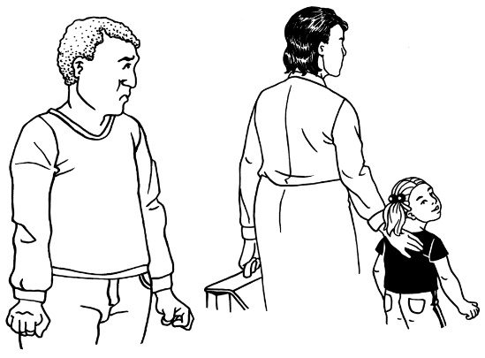 | The support will help stop things going wrong.
Recommendation 3
 | Parents with a learning disability should get the support they need before the birth of their child and also after the birth.

Recommendation 4

     | Parents should get support through each stage of the growth of their child.

Recommendation 5

  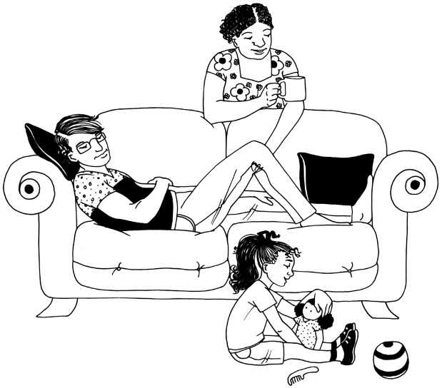 | Support should be for both the parents and the children  This means supporting the family with everything that is making it hard to be a good parent.

Recommendation 6
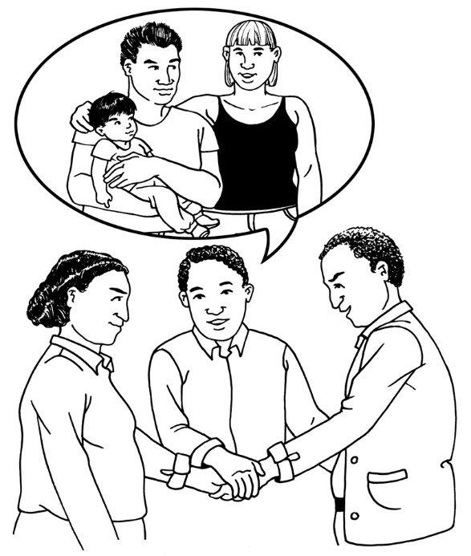 | The best way to organise whole family support is to work as a team.  The team will be  Social Workers  Health Staff  Childcare Workers  and others.
Recommendation 7
 | Services available to all parents should get better at working with people with learning disabilities.
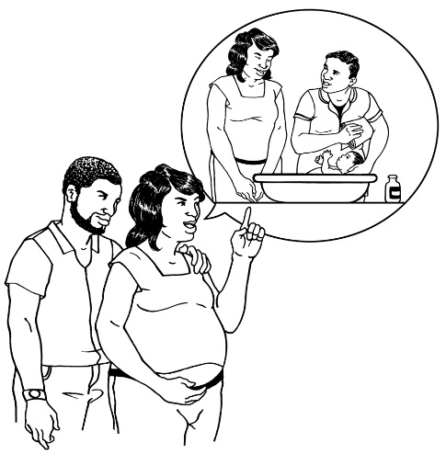 | Parents with learning disabilities might also benefit from special support for their needs.
   | Parents with learning disabilities should be supported to meet other parents with learning disabilities.  This is because they will have had the same type of experiences.

Recommendation 8
   | There should be a plan for giving clear information to parents.  This plan should be based on what works well and what does not work well.  There should be enough money to make sure the things in the plan happen.

Recommendation 9
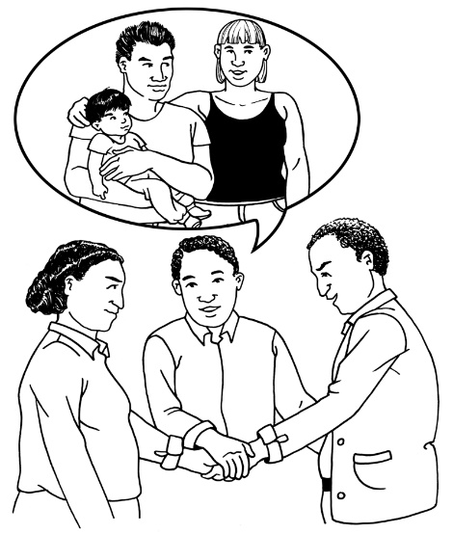 | It is important to share good ways of working with parents with learning disabilities
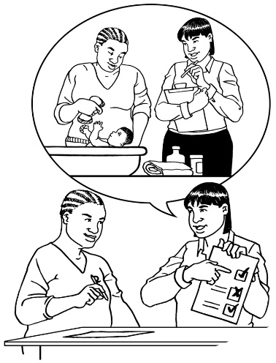 | This should include agreed assessments to decide how well a parent can support a child.
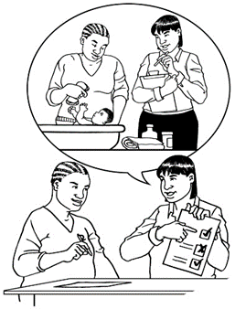 | An assessment is a way to test how well a person is doing something.
 | This should also include easy to understand information for parents with learning disabilities.
Recommendation 10
 | People who work with parents and children should get training on how to work well with parents who have a learning disability.

Recommendation 11
 | We need to get information about how these recommendations have made a difference to parents with learning disabilities.
 | This is to find out if the recommendations have helped or if they have not helped.
Recommendation 12
 | We need to ask parents with learning disabilities about what has helped and what has not helped them to be good parents

More about the report

 | Having a learning disability does not mean a person cannot be a good parent.
 | People with learning disabilities can be good parents with the right support.
 | Parents with learning disabilities might need more support while their child is growing up
 | The law says that parents with learning disabilities must get the right kind of support
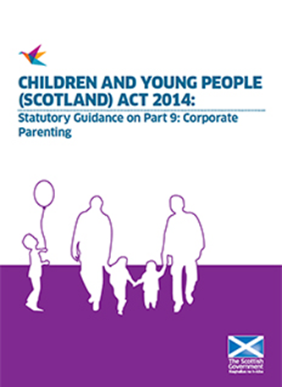 | This law is called Part 12 of The Children and Young People Scotland Act.
 | The report says that the recommendations are there to help parents with learning disabilities to get the best help.

