SCLD Trustee About You and Responsibilities
 | The SCLD Board is looking for people with different views and experiences.
 | We want to hear from people of all abilities and backgrounds.
 | You do not need to have been on a Board before.
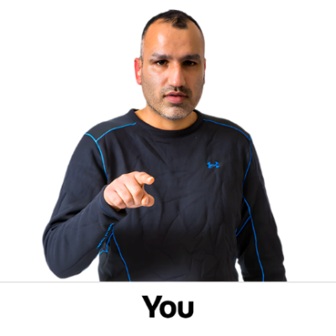 | What matters is the experience you can bring.
Experience
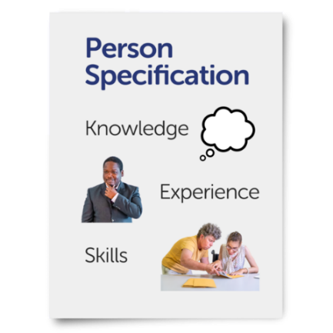 | We are looking for people with experience in some of the following things:
 | Supporting people to overcome inequalities and get their human rights.
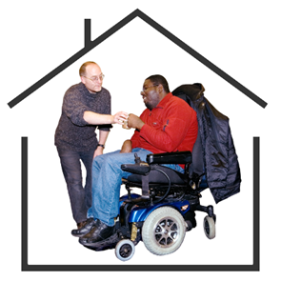 | Supported or inclusive community living.
 | Leadership in health, social care, or learning disability services.
 | Supporting people with disabilities to live full and meaningful lives.
 | Raising money for charities.
 | Campaigning on important issues.
 | Managing how an organisation works.
 | Digital and using technology to make people’s lives better.
 | Knowledge and experience of the rules charities have to follow.
 | Senior leadership in a charity.
 | Leading or helping with meaningful change.
 | Helping organisations to make long term plans.
How you will help the Board
 | You will be joining a supportive Board that is passionate about helping SCLD make things better for people with learning disabilities.
 | You will help the Board guide SCLD by:
 | Being interested in the lives of people with learning disabilities.
 | Learning about how SCLD operates and has an impact.
 | Committing the time needed to play your part in the Board.
 | Supporting decisions the Board has to make.
How you will help the board to think differently
 | You will help the Board think differently by:
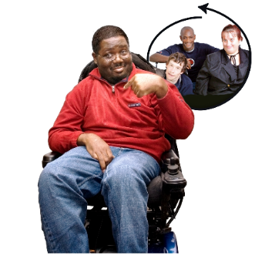 | Using your own lived experience.
 | Bringing your own views to Board discussions.
 | Challenging others in helpful ways.
 | Suggesting how to make the Board work better.
 | Making sure the voices of people with learning disabilities is at the heart of our work.
What you will be expected to do
 | You will use skills to support all of the things listed above.
Responsibilities
 | Board members have lots of responsibilities.
 | These responsibilities are listed below:
Governance
 | Contribute at Board meetings and help make sure decisions are acted on.
 | Help make plans and policies for SCLD and make sure they are working.
 | Help make sure SCLD has enough money and is spending it right.
 | Hire people who can make sure SCLD has spent money legally and reported this right.
 | Make sure SCLD follows all the rules it must follow.
 | Support and challenge SCLD’s Chief Executive and leadership team.
Leadership and strategy
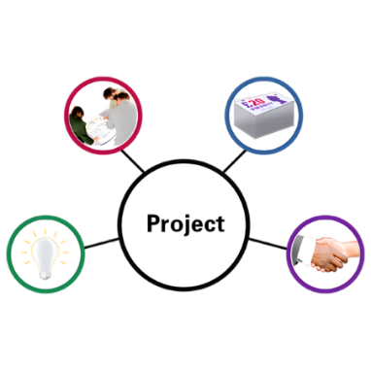 | Help develop SCLD’s mission vision and values.
 | Provide leadership which helps all the SCLD staff team do their jobs well.
 | Represent SCLD externally if you need to.
 | Promote SCLD.
 | Review and agree which people can make different decisions on behalf of SCLD.
 | Regularly think about the external environment and how to develop SCLD’s strategy.
Risk Management
 | Keep an eye on the main risks facing SCLD.
 | Look over SCLD’s risk management system.

