
Easy Read Guide
SCLD Priorities for Change

Design Services to be More Inclusive

  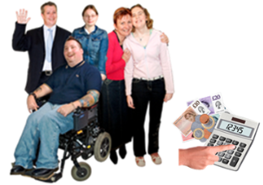 | Make sure organisations who get money from the Scottish Government know how to include and support people with learning disabilities.
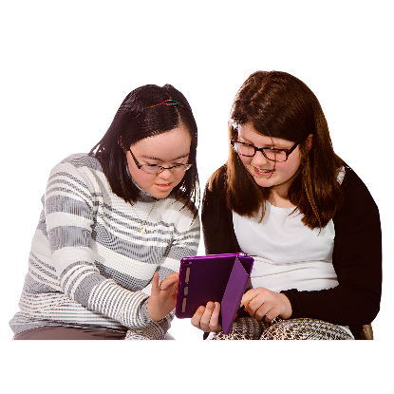 | Help make digital services easier to use and help people with learning disabilities to use technology on their own.
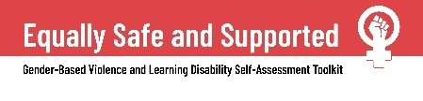  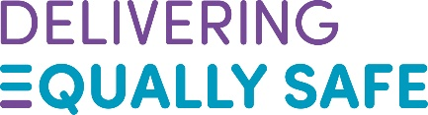 | Keep funding the Delivering Equally Safe programme to help improve and share tools like the Equally Safe and Supported Self-Assessment Toolkit.
 | The Delivering Equally Safe is programme of work by the Scottish Government to help stop violence against women and girls.
  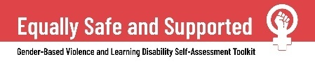 | The Equally Safe and Supported Self-Assessment Toolkit has been made to help organisations who support women who have experienced gender-based violence.
 | Gender based violence means a woman or girl being treated badly or hurt because they are a woman.
   | Provide full and inclusive support to any family that needs it, just as The Promise has said.
 | The Promise is the Scottish Government’s plan to make the care system better for children and young people by 2030.

